Israel-Hamas War
What is the witness of the church?
Presentation and Power Point – Amgad Beblawi, Ministry and Mission Executive
for the Presbytery of Des Moines (*Bio below)

Thursday, FEB. 8, 2024; 7:00 PM
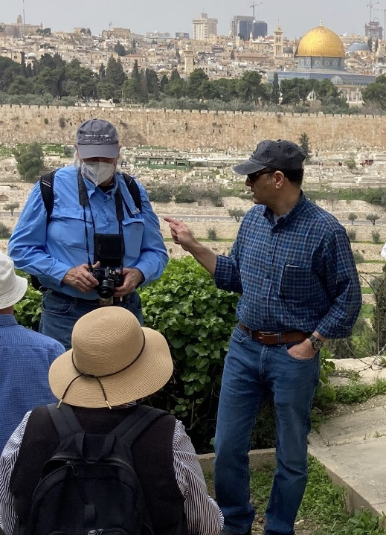
NW Community Center, 5110 Franklin Ave. DM

Amgad, with a Presbyterian delegation on Mount of Olives over-looking Jerusalem.

“…we respond to Christ’s call to − be peacemakers, to speak the truth in love, to speak on behalf of those who cannot speak for themselves, and to do so in ways that point to Christ who sent us into the world to exhibit the kingdom of God.”

Photo credit, Julie & Doug Olson

Amgad will share his expertise, and his power point photos, to give witness to the unfolding crisis in Gaza through the lens of history, theology, and his numerous visits in Palestine-Israel.

The presentation will be followed with a Q & A period.
****
*Amgad Beblawi is Ministry and Mission Executive for the Presbyteries of Des Moines, North Central Iowa, and Prospect Hill. A lifelong Presbyterian, He is a ruling elder and previously served as coordinator of the PCUSA’s mission and partnerships in Europe and the Middle East and travelled extensively in both regions. Amgad is a graduate of Fuller Theological Seminary, California. His interests include Christian Ethics, church unity and ecumenical relations, and the church’s global and local witness. A native of Egypt, Amgad immigrated to the United States in 1985 and is married to Susan Templet Beblawi. Amgad and Susan have an adult son, Justin, who lives in California.
Sponsored by Catholic Peace Ministry, Middle East Peace Education Coalition (MEPEC)

